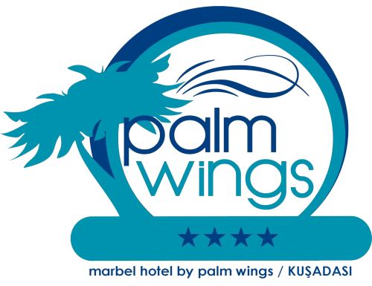

MARBEL HOTEL BY PALM WINGS // KUSADASI

2016 -- FACT SHEET

HOTEL NAME | MARBEL HOTEL BY PALM WINGS
CLASSIFICATION | 4*
ADDRESS | KİTAŞ ADALIOĞLU SİT. SÖKE YOLU ÜZERİ KUŞADASI / AYDIN
TELEPHONE | 0 256 6147100
FAX | 0 256 6142909
WEB | www.marbelhotel.com.tr ; www.palmwings.com.tr
E-MAIL | marbel@palmwings.com.tr ; marbel.reservation@palmwings.com.tr
OWNER | BAZMER TURİZM OTELCİLİK HİZMATLERİ A.Ş.
GENERAL MANAGER | RESUL AKBAŞ
FRONT OFFICE MANAGER | HASAN ERCAN
YEAR OF RENOVATION | 2013
NUMBER OF FLOORS | 7
LIFT | 3
DISTANCES | İzmir ADB Airport 70 km 55 min by car
 | City Center 800 m 15 min by walk
 | Bus Station Near The Hotel
 | Ephesus 15 km
CONCEPT | ALL INCLUSIVE
ROOM FACILITIES & EQUIPMENT | Total number of rooms 105
 | 95 Standart room
 | 7 Connection rooms
 | 1 Disabled room
 | 2 Family room
In Standart rooms |  |  | In Family rooms
LCD Screen TV |  |  | LCD Screen TV
Bathroom |  |  | Bathroom
Satellite TV |  |  | Satellite TV
Minibar |  |  | Minibar
Hair Dryer |  |  | Hair Dryer
Direct Dial Telephone |  |  | Direct Dial Telephone
Individual Air-conditioning |  |  | Individual Air-conditioning
Balcony |  |  | Balcony
Electronic Lock Key |  |  | Electronic Lock Key
Electronic Safety Box |  |  | Electronic Safety Box
Carpet floor (15 room ceremic floor) |  |  | Carpet floor
FREE INTERNET WI-FI
General Area and in all rooms
HOTEL FACILITIES & SERVICES
 | Total Area 7.660 m²
 | Outdoor Pool
 | Children Pool
 | Sunbeds Free
 | Umbrellas Free
 | Pool Towels (with charge)
 | Restaurant (Indoor Rest.) 1 (230 Pax)
 | Garden ( Outdoor restaurant) 1 (200 pax)
 | Bars 2
 | TV Room 1
 | Meeting Room 80 pax
 | Hair Dresser with charge
 | Dry Cleaning with charge
 | Laundry with charge
 | Room Service with charge
 | Turkish Bath with charge
 | Foam Massage with charge
 | Sauna with charge
 | Massage with charge
 | Billiards with charge
 | Mini bar with charge
 | Doctor (On call upon request) with charge
 | Pool Towels with charge
 | Fitness Center Free
 | Table Tennis Free
 | Tennis (Day Time ) Free
 | AC in Lobby
BEACH | Free Shuttle Service to the Beach
ANIMATION | Soft Animation
CREDIT CARD | Visa,Master

