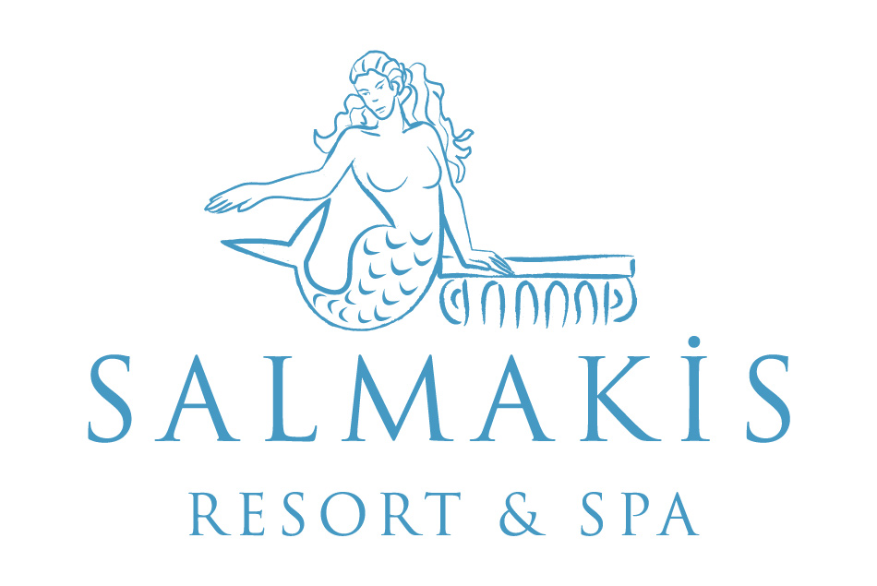

ALL INCLUSIVE CONCEPT & FACT SHEET SUMMER 2017

DISTANCES |  | YEARS OF CONSTUCTION | 1996
TO THE CITY CENTER (BODRUM) | 1 KM | LAST RENOVATION | 2013
AIRPORT | 35 KM
GÜMBET | 1 KM | SEASON | 01.04. – 31.10.2017
ADRESS | SALMAKİS RESORT & SPA  BARDAKÇI KOYU  BODRUM / MUĞLA | BOARD | ALL INCLUSIVE
WEB SITE | www.salmakis.com.tr | TOTAL AREA | 22.000 m²
E-MAIL | salmakis@salmakis.com.tr | AIR-CONDITION / HEATING | 24 hrs SPLIT / Central
TEL | +90 252 316 65 06 / 07 | TOTAL ROOM | 212
FAX | +90 252 316 65 11 | CAPACITY | 424

ROOM DETAILS | STANDART | FAMILY | JUNIOR SUIT | KING SUIT
Number of Bedrooms with Sea view | 107 | 15 | 2 | 1
Number of Bedrooms with Garden view | 75 | 10
Sitting Room
Size | 25 m² | 40 m² | 75 m² | 94 m²
Min.- Max. Occupancy | 1 / 2 | 1 / 3+1 | 1 / 3+1 | 1 / 3+1
Balcony
French balkon | - | - | - | -
Terrace |  |  | - | -
Non-smoking rooms
Disabled rooms | 2 | - | - | -
Tub / WC
Hair dryer
Air condition / Heating
Direct Dial Telephone
Wi - Fi
Minibar
Room Floor carpet+faience
Safe Box
Energy saver
Satellite TV LCD
Music Channel( on TV)
RESTAURANTS | BARS
Main Restaurant: 1 | Restaurant Bar, Pool Bar, Beach Bar, Lobby Bar
A ‘la Carte Restaurant: 1 | CONFERENCE & MEETING ROOMS
Poseidon Fish A’la Carte Restaurant | 1
 | BEACH
DISCO Not available | Sand + Pebbles
 | Private Beach 60 m
POOLS | 1 Pier , Blue Flag
Adult Pool 300 m² / 140 cm | ENTERTAINMENT
1 Children’s Pool 5.5 m² / 40 cm) | Daytime sports activities,evening music activities,DJ performance and Live music
Indoor Pool 68.5 m² / 1,60 cm | DOCTOR
 | Doctor on charge and on request. Nurse, all medical service are with charge
 | PETS Not allowed

MINI CLUB 10:00 – 12:30 / 14:30 – 17:30 | SHOPPING CENTER
0 - 3 ages: Babysitting on request with charge | Mini Market, Hair dresser, photographer
4 – 12 ages: Playground | SPOKEN LANGUAGES
 | English, French, German
 | SPORT ACTIVITIES
CREDIT CARDS Master, Visa | Tennis, fitness center, dart, table tennis, boccia,aerobic,step,billiards,air gun.
FOOD
Breakfast  Lunch  Dinner  Midnight snack | Main restaurant | 07:00 – 11:00  12:30 – 14:30  19:00 - 21:30  23:45 – 00:30
A la Carte Dinner | A la Carte Restaurant | 20:00 – 22:00
Snack | Snack Restaurant | 12:30 – 17:00
Ice Cream | Main Restaurant | 12:00 – 14:30 / 19:00 – 21:30
Tea,coffee,cookie time | Snack Bar | 17:00-18:00
Cakes, pastries, desserts | Lobby Bar | 10:00 – 00:00

BEVERAGES
All local alcoholic, non alcoholic drinks are free of charge. Canned drinks are extra charge.Some import/Local alcohol drinks are free of charge. | Restaurant Bar | 12:30 - 14:00  19:30 - 21:30
 | Lobby Bar | 24 Hours
 | Beach Bar | 10:00 – 18:00
 | Pool Bar | 10:00 – 01:00
Water, cola, fanta, sprite, soda,beer are extra charge.1 small bottle of water is every day free of charge | Mini Bar | EVERY DAY

FAMILY CONCEPT
Mini Club  4 - 12 ages | Activities with charge  - Baby sitting service with on request
The activities in the Mini Club  Playground, Sleeping Room and TV room, Face and body painting, Red Indian day, Pirate day, Birthday parties | Other facilities for the children in the hotel:  - 1 kids pools  - Baby coat in the room and on request  - High chair in the A’la carte restaurant and main restaurant
HONEYMOON CONCEPT
- Basket of fruits, wine and one rose in the room on the arrival day.
- Bathrobe, slippers in the rooms
- A honeymoon breakfast service at the room for once during the stay. The guest relations will take contact with the honeymoon couple.
- A reservation for the A la Carte Restaurant in advance
- 20 % discount on massage parlors

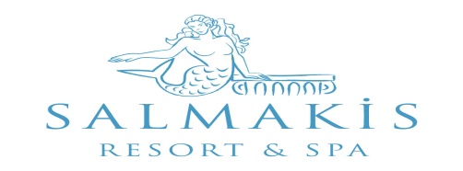

ACTIVITIES |  | With Charge | Free
A la Carte Restaurants ( with reservation ) | 15.05.- 15.10.2014 During the stay A la Carte restaurant can be booked only once and regarding to weather and availability

Hamam ( Turkish bath)

Sauna

Massage

Fitness Center

Dart

Wireless Internet Connection

Table Tennis (Ball and rackets)
Tenis Courts (Ball and Rackets) | With deposit

Billiards

Boccia

Mini Club

Business Center

Laundry

Sunshade, Mattress, Sun Beds, Towel

Baby Sitting

TV & Game Room

Indoor Pool & Jacuzzi

Soft Animation

Parking

Telephone, fax services

Safe Box

All import drinks and special wines & after 01:00 a.m all drinks

Fresh Orange juice

Mini Bar

1 bottle of watter for per person is free of charge

Doctor, Medical Service, Medicine

Steam Room

Body Peeling

Therapy

Beauty Center

Shops

Tennis (Floodlight)

Mini Market, Hairdresser, Photographer

Opening terms of the outlets could be changed according to the weather conditions and occupancy.

ÖDÜLLERİMİZ VE B

BLUE FLAG
Tripadvisor – Sertificate of Excellence 2013 / 2014 / 2015 / 2016
Recommended on Holidaycheck 2014
Zoover Highly Recommended Award 2013 / 2014

Zoover Award Winner Bronze 2015 /2016

Trivago – Best Beachfront Hotel 2013

