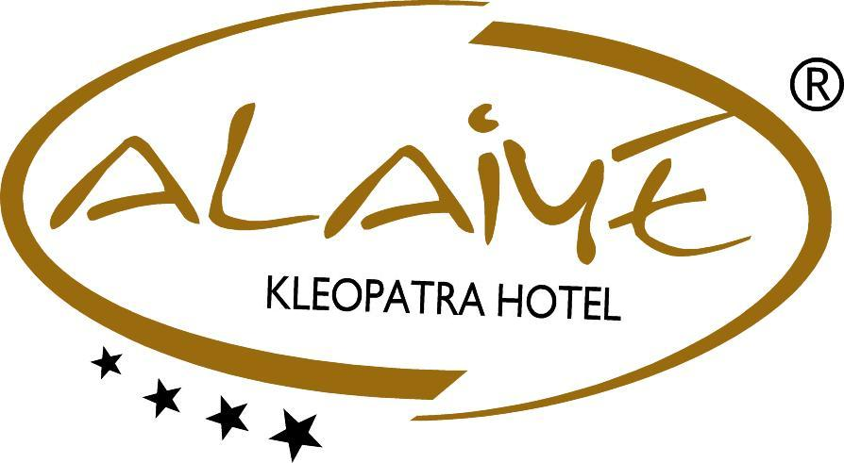

2017 SUMMER CONSEPT

ALAIYE KLEOPATRA HOTEL

Location: Our place is 100 tm away from the magnificent Kleopatra beach, 1 km to Centrum, 2 km from central bus station, 3 km to Alanya's castle, 45 km to Gazipaşa airport and 120 km to Antalya airport. Our hotel has totally 107 rooms and 213 beds where built on a 1700 m2 land.

Tel : +90 242 513 40 18
Faks : +90 242 512 15 08
E-mail : alaiye@alaiye.com.tr
Web : www.alaiyehotels.com
Address : Saray Mahallesi, Ataturk str. No: 150
07400 / Alanya / Antalya / TÜRKİYE

HOTEL INFORMATION

HOTEL NAME : ALAIYE KLEOPATRA HOTEL

CATEGORY : 4 Stars

CONSEPT : All

AVAILABILITY : 12 months

SPEAKING LANGUAGES : Turkish, English, Deutsch

BEACH : Sand-certificated by blue flake

BEACH COSTS : Sunbed, cushion, umbrella, food and beverage

LAST RENOVATİON : 2013

GOOGLE MAPS : LG (Longitude): 31.98251250793453
LT (Latitude) : 36.54849933348661

STANDARD ROOM / 30 ROOMS (16 M2)

* Orthopedic Beds
* Two single beds
* 82- Screen LED TV (32´´)
* HD Satellite (250 channels) Local and Foreign
* Direct-dial telephone in room and bathroom
* Safe Deposit Box (Extra Charge)
* With power sockets and laptop size
* Mini fridge (empty)
* Split air conditioning (hot / cold)
* Wallpaper / Laminate flooring
* Bathroom / WC / Shower cabin
* Hair dryer
* Wi-Fi internet (free of charge)
* Balcony with table and chairs
* Either direct or side sea view
* Min.1 adult Max. 2 adults.

STANDART ROOM 1 / 53 ROOMS (16 M2)

* Orthopedic Beds
* One single beds
* One double bed
* 82- Screen LED-TV (32´´)
* HD Satellite (250 channels) Local and Foreign
* Direct-dial telephone in room and bathroom
* Safe Deposit Box (Extra Charge)
* With power sockets and laptop size
* Mini fridge (empty)
* Split air conditioning (hot / cold)
* Wallpaper / Laminate flooring
* Bathroom / WC / Shower cabin
* Hair dryer
* Wi-Fi internet (free of charge)
* Balcony with table and chairs
* Either direct or side sea view
* Min.1 adult Max. 3 adults.

CONNECTED ROOM / 20 ROOMS (32 M2)

* Orthopedic Beds
* Two single beds
* 82- Screen LED TV (32´´)
* HD Satellite (250 channels) Local and Foreign
* Direct-dial telephone in room and bathroom
* Safe Deposit Box (Extra Charge)
* With power sockets and laptop size
* Mini fridge (empty)
* Split air conditioning (hot / cold)
* Wallpaper / Laminate flooring
* Bathroom / WC / Shower cabin
* Hair dryer
* Wi-Fi internet (free of charge)
* Balcony with table and chairs
* The standard consists of two rooms with balcony (with a door)
* Either direct or side sea view
* Min.2 adults. Max,4 adults.

HONEYMOON ROOM / 2 ROOMS (16 M2)

* Orthopedic Beds
* Custom size 180x200 cm bed
* 82- Screen LED-TV (32´´)
* HD Satellite (250 channels) Local and Foreign
* Direct-dial telephone in room and bathroom
* Safe Deposit Box (Extra Charge)
* With power sockets and laptop size
* Mini fridge (empty)
* Split air conditioning (hot / cold)
* Wall paper / Tile flooring
* Bathroom / WC / Jacuzzi
* Hair dryer
* Wi-Fi internet (free of charge)
* Balcony with table and chairs
* Direct sea view

HANDICAPPED ROOM / 2 ROOMS (16 M2)

* Orthopedic Beds
* Two single beds
* One double bed
* 82- Screen LED-TV (32´´)
* HD Satellite (250 channels) Local and Foreign
* Direct-dial telephone in room and bathroom
* Safe Deposit Box (Extra Charge)
* With power sockets and laptop size
* Mini fridge (empty)
* Split air conditioning (hot / cold)
* Wallpaper / Tile flooring
* Bathroom / WC / Shower
* Hair dryer
* Wi-Fi internet (free of charge)
* Balcony with table and chairs
* Specially equipped for wheelchair access
* Either direct or side sea view
* Min.2 adults. Max. 3 adults.

** Only at the first arrival day there are; water, mineral water and fruit juice at our minibars

** Daily Towel changes

** Daily room cleaning

** Sheets are changing in 3days

** Rooms are preparing special for the honeymooners. There are bathrobes, slippers. Wine and fruit basket can serve too.

HOTEL SERVICES

ALL INCLUSIVE /FREE SERVICES

    - Between 10:00-23:00 all local alcohols and local soft drinks
    - Between 10:00-23:00 all teas, coffees, cappuccino, espresso
    - Breakfast : 07:00 – 10:00
    - Late Breakfast : 10:00 – 10:30 (summer season)
    - Snack Bar : 11:30 – 16:30 (summer season)
    - Lunch : 12:30 – 14:00
    - Coffee Break : 17:00 – 18:00
    - Dinner : 19:00 – 21:00
    - 24 hours room air-condition
    - Outside - indoor pool
    - Sun beds and umbrellas at the pool
    - Fitness center, Jacuzzi
    - Table tennis
    - Evening animation activities (summer season)
    - Wifi-fiber internet in all rooms and whole places at the hotel

EXTRA SERVICES

- All imported drinks
- Turkish coffee and fresh fruit juices (season fruits)
- All kind of ice cream
- Safe boxes at the room
- Room services
- Laundry services
- Int. Cafe, bilard
- Telephone, fax, copy
- Hairdresser, juwellery, photographer
- Turkish bath, sauna, steam room, massage and peeling
- All beach services(beach towels, sunbeds, umbrella, food and beverage)
- Doctor
- Rent a car
- All water sports
- Transportation transfer service
- Special day celebrations, without or concept

RESTAURANT VE BARS

MAIN RESTAURANT

Our main restaurant which consists of Turkish and world cuisine, has a rich open buffet, will have unforgettable flavors at special theme nights,150 people capacity, with a perfect breakfast, lunch and dinner, to serve our dear guests.

MAIN RESTAURANT

SELCHUK RESTAURANT : 150 person

BREAKFAST, : 07: 00 – 10: 00

LATE BRAKFAST : 10: 00 – 10: 30 (summer season)

LUNCH, : 12: 30 – 14: 00

DINNER, : 19: 00 – 21: 00 (winter: 18:00 – 20:00)

OUTLET

SNACK BAR : 11: 30 – 16: 30 (summer season)

COFFE BREAK (TEA, COFFE, CAKE) : 17: 00 – 18: 00

BARS

POOL BAR : 10: 00 – 18: 00 (summer season)

PUZZLE BAR : 10: 00 – 02: 00

BEACH & SNACK BAR : 08: 00 – 18: 00 (summer season)

OTHER INFORMATION,

** Pool can use between :08:00-19:00

** Visa and master cards can use

** Pets can't accept

** The law required the republic of turkey; alcohol can not be served under the 18 years of age

** The law required the republic of turkey; it is forbidden and punitive to smoke at enclosed areas

** Depending on weather conditions, we may have to change an unspecified date, time and place

** Arrival time is: 14:00 check out time is 12:00 if you want to use the room after 12:00 Reception
should be informed one day before then check out time

** Hotel management is not responsible from your lost and stolen items

We are not responsible without our given informations

