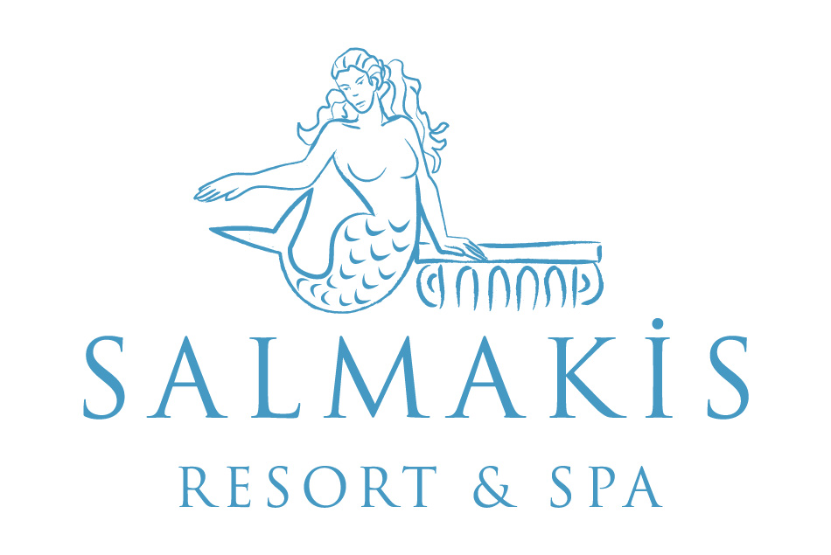

ALL INCLUSIVE CONCEPT & FACT SHEET SUMMER 2018

DISTANCES |  | YEARS OF CONSTUCTION | 1996
TO THE CITY CENTER (BODRUM) | 1 KM | LAST RENOVATION | 2013
AIRPORT | 35 KM
GÜMBET | 1 KM | SEASON | 01.04. – 31.10.2018
ADRESS | SALMAKİS RESORT & SPA  BARDAKÇI KOYU  BODRUM / MUĞLA | BOARD | ULTRA ALL INCLUSIVE
WEB SITE | www.salmakishotel.com | TOTAL AREA | 22.000 m²
E-MAIL | salmakis@salmakis.com.tr | AIR-CONDITION / HEATING | 24 hrs SPLIT / Central
TEL | +90 252 316 65 07 | TOTAL ROOM | 212
FAX | +90 252 316 65 11 | CAPACITY | 424

ROOM DETAILS | STANDART | FAMILY | JUNIOR SUIT | KING SUIT
Number of Bedrooms with Sea view | 107 | 15 | 1 | 1
Number of Bedrooms with Garden view | 76 | 10
Sitting Room | x
Size | 25 m² | 40 m² | 75 m² | 94 m²
Min.- Max. Occupancy | 1 / 3 | 1 / 3+1 | 1 / 3+1 | 1 / 3+1
Balcony
Terrace |  |  | - | -
Non-smoking rooms
Disabled rooms | 2 | - | - | -
Tub / WC
Hair dryer
Air condition / Heating
Direct Dial Telephone
Wi - Fi
Minibar
Room Floor carpet+faience
Safe Box
Energy saver
Satellite TV LCD
Music Channel( on TV)
RESTAURANTS | BARS
Main Restaurant: 1 (350pax) | Restaurant Bar, Pool Bar, Beach Bar, Lobby Bar
A ‘la Carte Restaurant: 1 | CONFERENCE & MEETING ROOMS
Poseidon Fish A’la Carte Restaurant | 1
 | BEACH
DISCO Not available | Sand + Pebbles
 | Private Beach 60 m
POOLS | 1 Pier , Blue Flag
Adult Pool 300 m² / 140 cm | ENTERTAINMENT
1 Children’s Pool 5.5 m² / 40 cm) | Daytime sports activities, evening music activities, DJ performance, night shows and Live music
Indoor Pool 68.5 m² / 1,60 cm | DOCTOR
 | Doctor on charge and on request. Nurse, all medical service are with charge
 | PETS Not allowed

MINI CLUB 01.05 – 15.10.2018 | SHOPPING CENTER
0 - 3 ages: Babysitting on request with charge | Mini Market, Hair dresser, photographer
4 – 12 ages: Mini Club | SPOKEN LANGUAGES
 | English, French, German
 | SPORT ACTIVITIES
CREDIT CARDS Master, Visa | Tennis, fitness center, dart, table tennis, boccia,aerobic,step,billiards,archery,air gun, water gym,zumba,water polo
FOOD
Breakfast  Lunch  Dinner  Midnight snack | Main restaurant | 07:00 – 11:00  12:30 – 14:30  19:00 - 21:30  23 :45 – 00:30
A la Carte Dinner | A la Carte Restaurant | 19:30 – 22:00
Snack | Snack Restaurant | 12:30 – 17:00
Ice Cream | Main Restaurant | 12:30 – 14:30 / 19:30 – 21:30 / 12:30-17:00
Tea,coffee,cookie time | Snack Bar | 17:00 - 18:00
Cakes, pastries, desserts | Lobby Bar | 10:00 – 24:00

BEVERAGES
All local alcoholic, non alcoholic drinks are free of charge. Some import/Local alcohol drinks are free of charge. | Restaurant Bar | 12:30 - 14:30  19:00 - 21:30
 | Lobby Bar | 24 Hours
 | Beach Bar | 10:00 – 18:00
 | Pool Bar | 10:00 – 24:00
Filled once with soft drinks at arrival(water refilled everyday) | Mini Bar | Filled at arrival

FAMILY CONCEPT
Mini Club 01.05. – 01.10.2017  4 - 12 ages | Activities with charge  - Baby sitting service with on request
The activities in the Mini Club  Playground, Sleeping Room and TV room, Face and body painting, Red Indian day, Pirate day, Birthday parties | Other facilities for the children in the hotel:  - 1 kids pools  - Baby coat in the room and on request  - High chair in the A’la carte restaurant and main restaurant
HONEYMOON CONCEPT
- Basket of fruits, wine in the room on the arrival day.
- Bathrobe, slippers in the rooms
- A honeymoon breakfast service at the room for once during the stay. The guest relations will take contact with the honeymoon couple.
- A reservation for the A la Carte Restaurant in advance
- 20 % discount on massage parlors

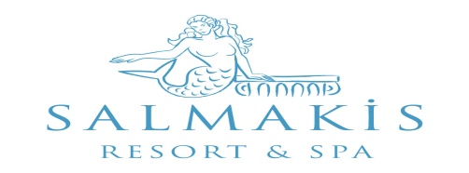

ACTIVITIES |  | With Charge | Free
A la Carte Restaurants ( with reservation ) | 15.05.- 15.10.2017 During the stay A la Carte restaurant can be booked only once and regarding to weather and availability

Hamam ( Turkish bath)

Sauna

Massage

Fitness Center

Dart

Wireless Internet Connection

Table Tennis (Ball and rackets)

Tenis Courts (Ball and Rackets)

Squash

Billiards

Boccia

Mini Club

Internet Room

Laundry

Sunshade, Mattress, Sun Beds, Towel

Baby Sitting

TV Room

Indoor Pool & Jacuzzi

Soft Animation

Parking

Telephone, fax services

Safe Box

All import drinks and special wines

Fresh Orange juice
Mini Bar | Filled once with soft drinks at arrival(water refilled everyday)

1 bottle of watter for per person is free of charge

Doctor, Medical Service, Medicine

Steam Room

Body Peeling

Therapy

Beauty Center

Tennis (Floodlight)

Mini Market, Hairdresser, Photographer

Opening terms of the outlets could be changed according to the weather conditions and occupancy.

Awards

BLUE FLAG
Tripadvisor – Sertificate of Excellence 2013 / 2014 / 2015 /2016
Recommended on Holidaycheck 2014 / 2015 / 2016
Zoover Highly Recommended Award 2013 / 2014 / 2016

Zoover Award Winner Bronze 2015

Trivago – Best Beachfront Hotel 2014

