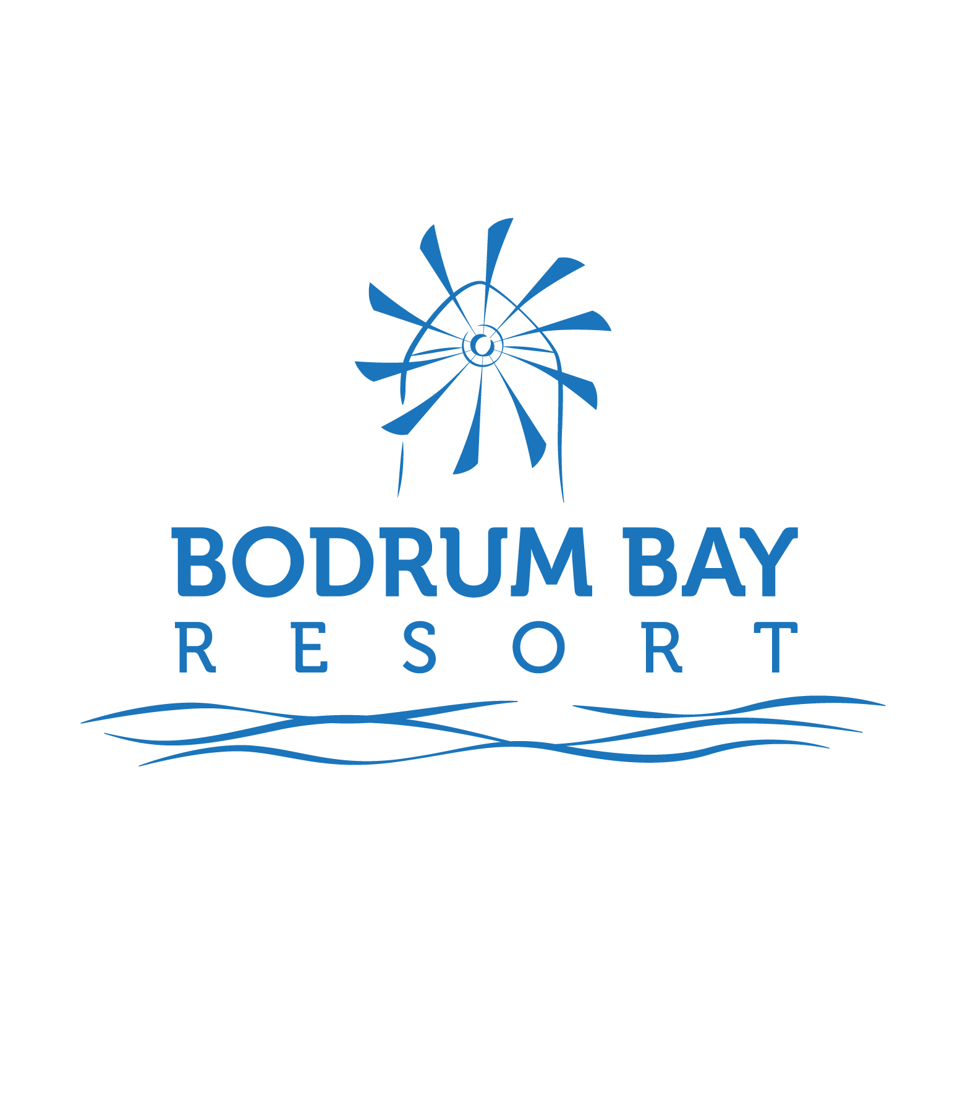 BODRUM BAY RESORT
(24 HOURS ALL INCLUSIVE 2018)

ADDRESS : Haremtan sok. Değirmenburnu Mevkii no:1 Bardakçı/Bodrum

TELEPHONE & FACSIMILE : t 0252 316 61 00 (pbx) f 0252 316 60 97

INTERNET ADDRESS (URL) www.bodrumbayresort.com

E-MAIL info@bodrumbayresort.com

HOTEL MANAGER Hasan Hüseyin FINDIK

LOCATION Located near by the centre of Bodrum on an area of 57.000 sq meters, with a view of Kos Island, Bodrum fortress and centrum of Bodrum.

CATEGORY

A hotel to be preferred for your trips both for holiday and purposes throughout the summer season.

ACCOMMODATION 24 Hours All inclusive
An open buffet breakfast, lunch and dinner with a rich variety of foods in the main restaurant, late breakfast, midnight soup service is free of charge between 24:00-01:00 and night snack between 01:00-05:00. A rich snack menu between 12:30 – 17:00, soft drinks and local alcoholic drinks 24 hours are offered free of charge. All import drinks, fresh fruit juices, all can & bottles of drinks and room service are extra of charge.

DISTANCE TO THE AIRPORT 35 km.
DISTANCE TO THE CENTER 1,0 km.
CAPACITY 270 rooms, 626 beds

TYPES/NUMBER OF ROOMS

HOTEL ROOMS (80 units)
min. 2 person - max. 3 person
(The room comprising of one bedroom for three persons in the main building. Floors are ceramics or hardwoods.Rooms has got bathtub)

CLUB ROOMS ( 190 units)
min.2 – max. 3 person
(The room comprising of one bedroom for two persons. Floors are ceramics. Rooms has got shower)

IN THE ROOMS HOT & COLD SPLIT AIRCONDITIONING
SATELITE TV
TELEPHONE
MİNİ-BAR (2 bottle of water free per day)
HAIR DRYER
SAFETY DEPOSIT BOX
BATHROOMS WITH BATHTUB IN THE ROOMS HOTEL SIDE
BATHROOMS WITH SHOWER IN THE ROOMS CLUB SIDE
ROOMS HAS TERRACE OR FRENCH BALCONIES
WITH OR WITHOUT SEA VİEW

ACTIVITIES (FREE OF CHARGES)
OUTDOOR POOL
FITNESS & GYM
SAUNA
TURKISH BATH
DART
TABLE TENNIS
AEROBIC
POOL GYMNASTIC
BEACH VOLLEY
BILLARD
MINI CLUB
KIDS PLAYGROUND

ACTIVITIES (CHARGE)
SCUBA DIVING
MOTORISED WATER SPORTS

OTHER FACILITIES
(FREE OF CHARGE) BACKGAMMON
CHESS
LIVE MUSIC
SHOW NIGHTS
MINI DISKO
INTERNET CORNER (IN COMMON AREAS)
MINI BAR ( 2 BOTTLE OF WATER PER DAY)

OTHER FACILITIES MASSAGE
( EXTRA OF CHARGE) LAUNDRY AND DRY CLEANING
ROOM SERVICE
TELEPHONE
RENT A CAR
HAIRDRESSER
DOCTOR
BABY SITTER
SAFEBOX (in room)

SHOPPING BOUTIQUE
PHOTOGRAPHER
SHOP
SOUVENIR

RESTAURANT SERVICE

Main Restaurant Main restaurant having sea view with a capacity for 120 persons in the indoors section and 250 persons in the outdoors section where breakfast, lunch and dinner are prepared comprehensively and offered in an open buffet.

*all import drinks are extra of charge

Breakfast : 07:00 – 10:00
Late breakfast : 10:00 – 11:00
Lunch : 12:30 - 14:00
Dinner : 19:00 – 21:00
Midnight Soup : 24:00 – 01:00

Snack Bar
Snack service hours : 12:30 – 17:00
Ice cream : 15:00 – 16:00

Lobby bar Cafe break : 17:00 - 18:00
(With turkish style pancake service)
Night Snack : 01:00 - 05:00

A LA CARTE SERVICE

A la Carte Restaurantes Restaurants which converts eating into a unique pleasure with its
splendid scenery.

Bodrum Eagean A’la Carte
(Drinks are extra)

Service hours : 19:30 – 21:30

* Free of charge for only once during the stay, all drinks are extra of charge , reservation is required.

BAR SERVICES

Service Bar Service bar located in the Main Restourant to service during the breakfast,lunch,dinner and midnight snack.

Service hours : During Meals

Lobby Bar Ready to offer services at any moment a day with its variety of choice

Service hour : 24 hours

Beach Bar An extraordinary place with its distinct decoration and ambiance where you can drink hot & cold drinks

Sevice hour : 10:00 – 18:00

Relax Bar Relax bar located at the outdoor pool area where you can find soft drinks.

Service hours : 18:00 – 02:00

**All imported dirinks are extra in all the bars. , fresh fruit juices, all can & bottles of drinks are extra of charge.

NRT TURİZM TİCARET A.Ş.
Barbaros Mahallesi Ihlamur Bulvarı C5 Blok
No:10-3 ATAŞEHİR / İSTANBUL
Kozyatağı V.D. No: 632 052 8279
Ticaret Sicil No: 49934-5

DENİZBANK SAHRAYICEDİT ŞUBESİ
TR08 0013 4000 0134 3350 6000 01

